Abhishek Ojha

Seat No 027

pRACTICAL NO 7

XML Database

**Practical 7: XML Database**

**Aim:**

Create a table employee having dept_id as number datatype and employee_spec as XML data type (XM_Type). The employee_spec is a schema with attributes emp_id, name, email, acc_no, managerEmail, dataOf Joning. Insert 10 tuples into employee table. Fire the following queries on XML database.

**Query:**

1. Retrieve the names of employee.
2. Retrieve the acc_no of employees.
3. Retrieve the names, acc_no, and email of employees.
4. Update the 3rd record from the table and display the name of an employee.
5. Delete 4th record from the table.

**Software Requirements:**

Oracle 11g Express Edition, Any browser.

**Practical Implementation:**

1. **Create Table Employee.**

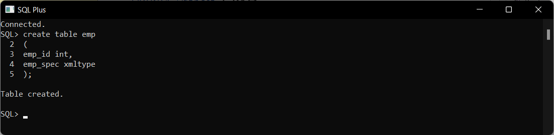

1. **Insert Some Records in Created Table.**

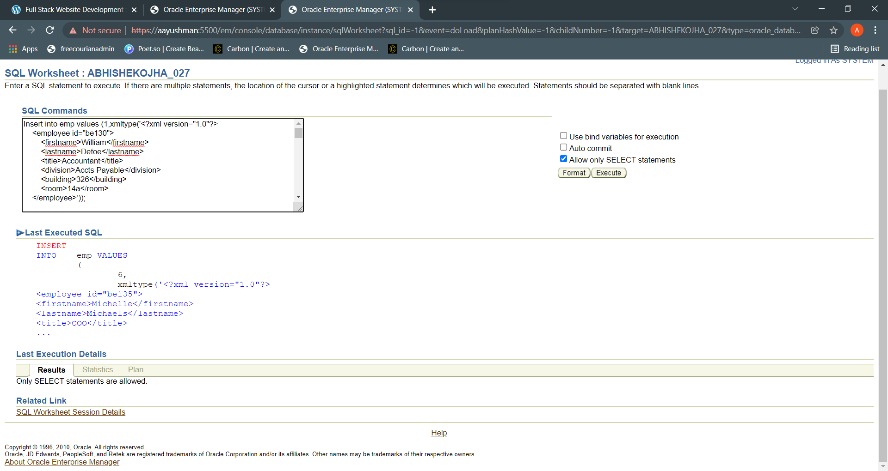

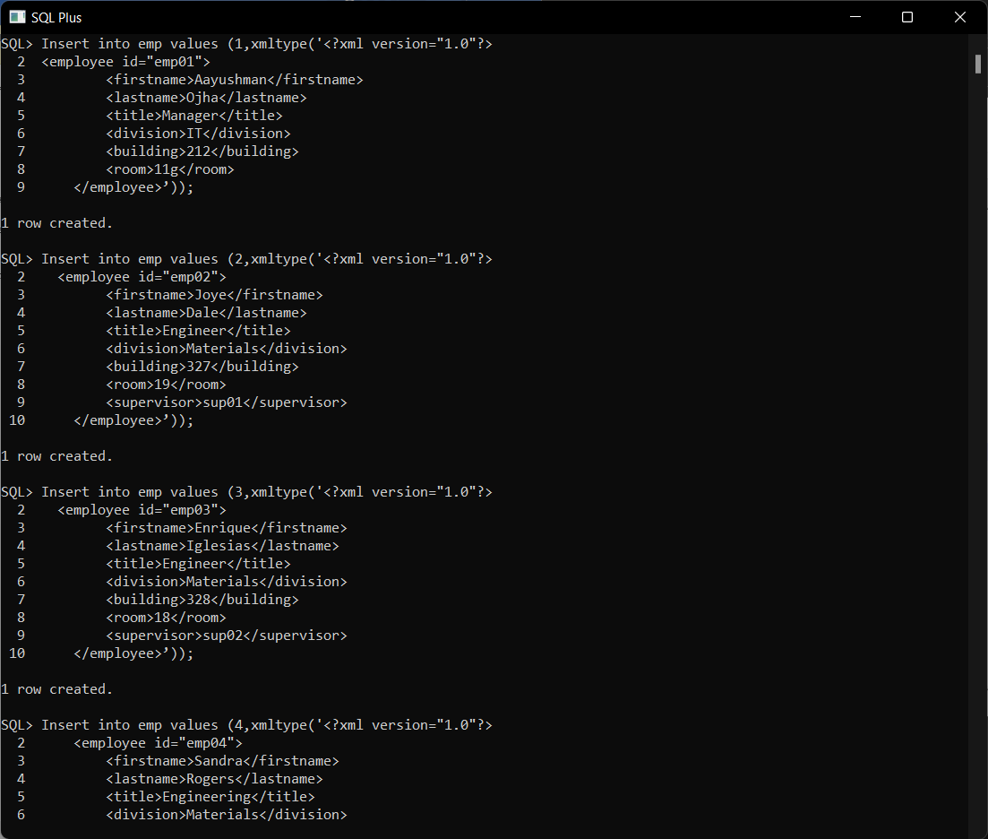

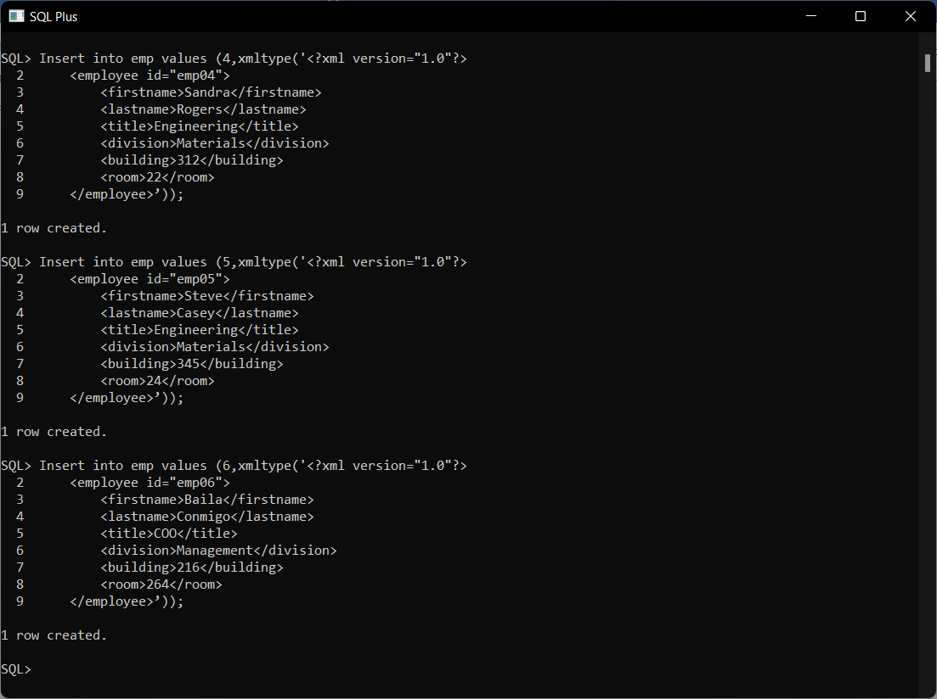

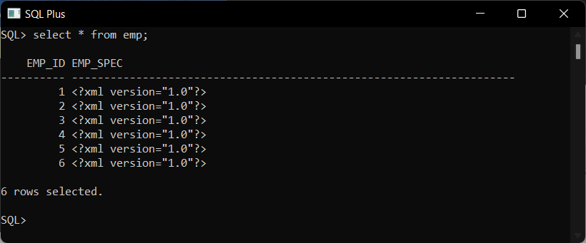

1. **Get the first name:**

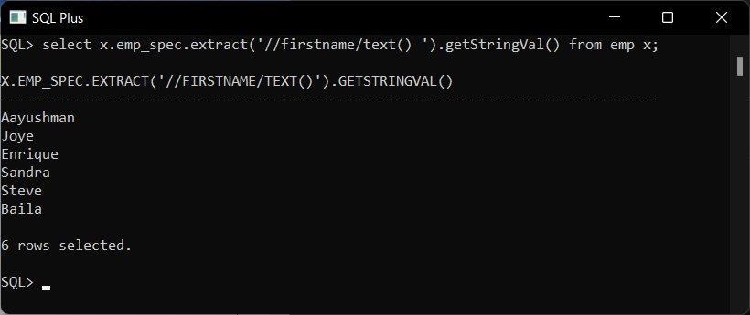

1. **Get the first name and room number.**

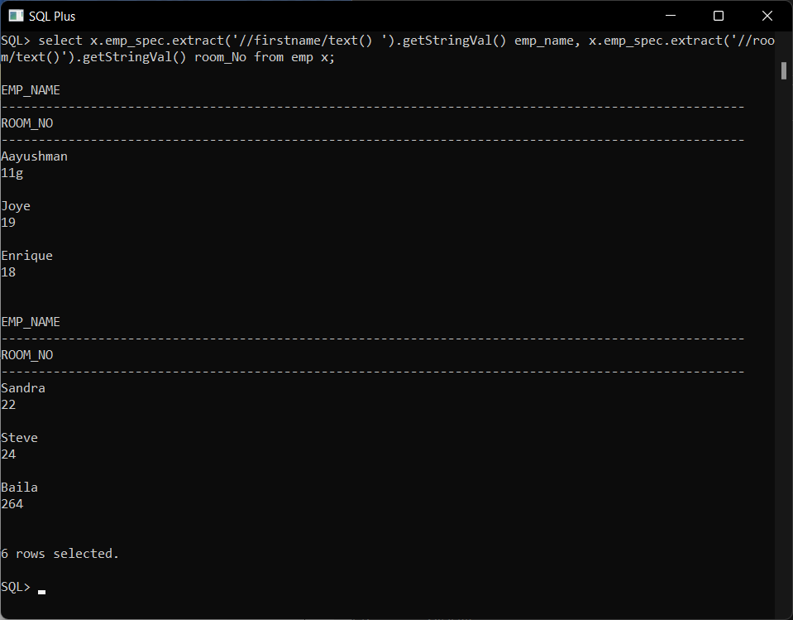

1. **Get the first name and room number and title.**

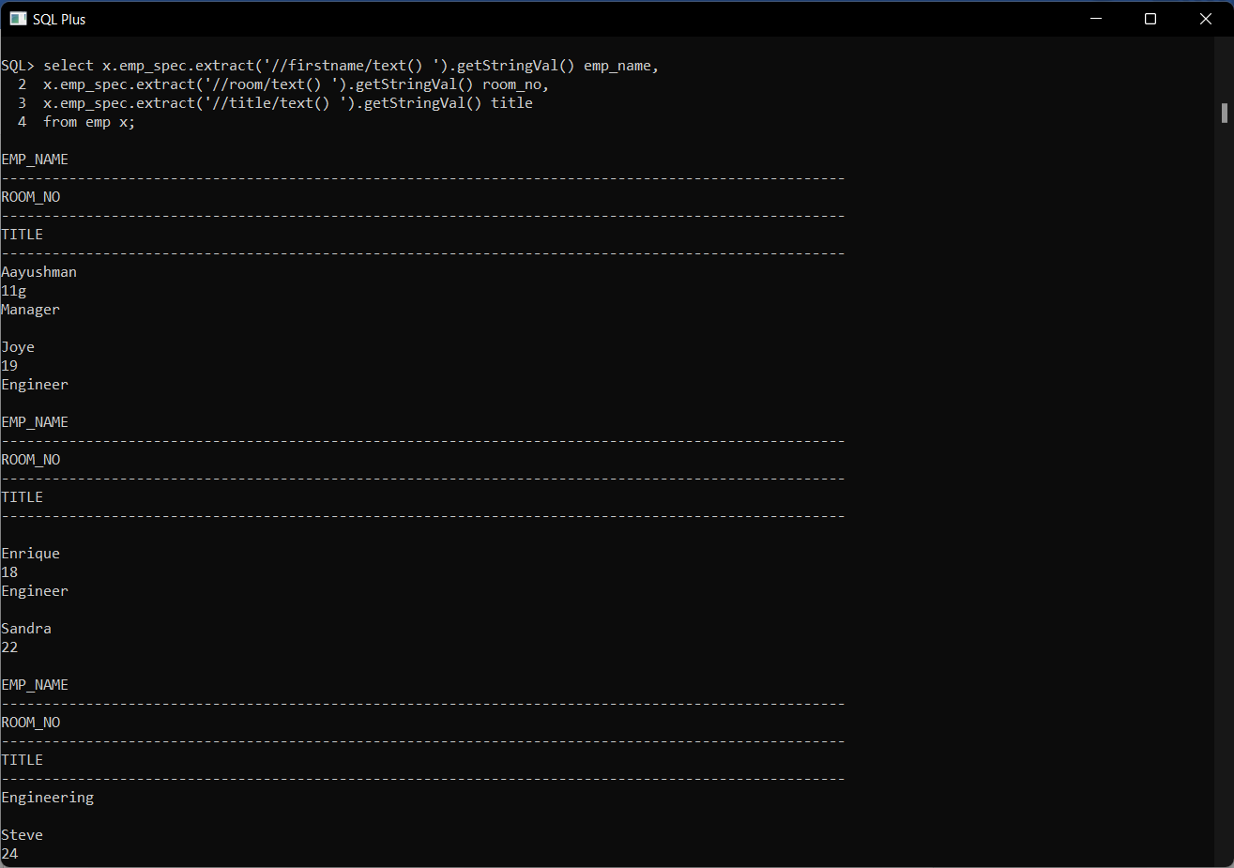

1. **Update 6th record from the table:**

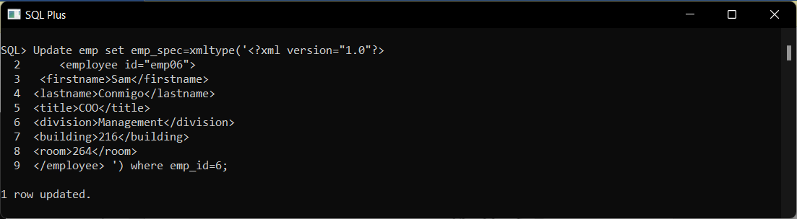

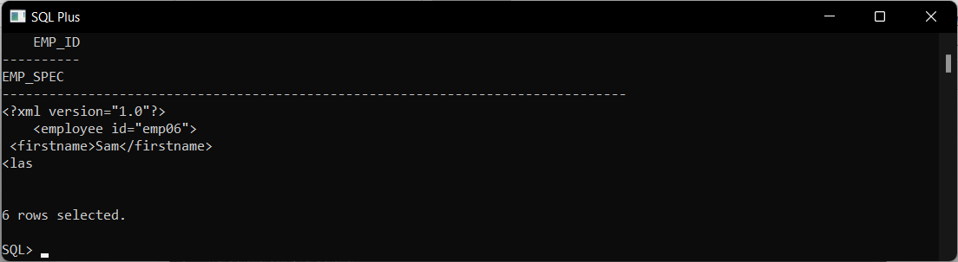

1. **Delete a record from the table:**



**Conclusion :-** Successfully Performed Operation like Create, Read, Update and Delete on XML Database.